Hill House is the One of the finest Independent Bungalow in Lonavala, Maharashtra. Spread over 6500 Square Feet Carpet Area..
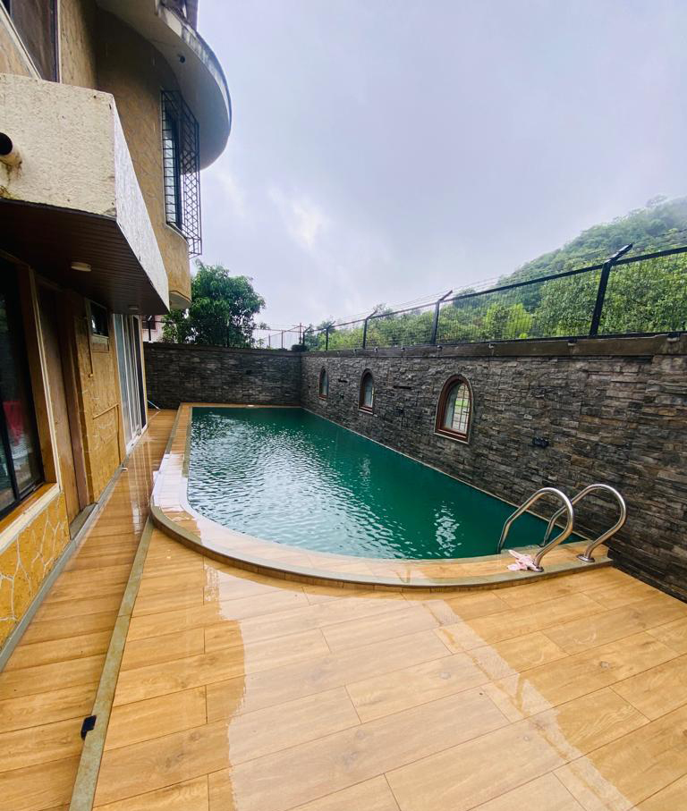

Hill House – can only be described as spectacular from just about every standpoint. The huge villa, built in the epicentre of mountains, has panoramic views. It has a humongous Garden for bonfire and barbecue. From the splendid entrance, through to the full-sized parking space, a terrace with Majestic Mountain Views & Garden with swing, every possible concept in the villa has been embraced.
Hill House is brilliantly accomplished, extremely comfortable and has aesthetically pleasing interiors. It includes all the comforts starting from cozy sofas to chill on, delightful lights to light up your holiday experience, elegant paintings to posh architecture. Each of the Six bedrooms have a distinctive theme, including two master suites and a well-equipped living room
The Villa flaunts a massive swimming pool and a Huge Garden Area, which leaves you awestruck with its sumptuous feel and enormous capacity. Hill House is the best place to have private outdoor pool parties. The bright lights and ambience will make your parties a hit with our finest hospitality and services.

The HILL HOUSE - A Perfect Monsoon Gateway. Amenities
• 6 BHK – 3 AC Rooms and 3 Naturally Ventilated.
• Majestic Mountain & Forest Views. (If Lucky can spot Peacocks, Sambars & Rabbits)
• Huge Playroom can be used for Indoor Games.
• CCTV Installed in Villa.
• Big Kitchen, Fully Furnished bungalow.
• Private Swimming pool.
• Private Garden with Slides and Gazeebo can be used for small events like
• WIFI Connection.
• Smart TV with DTH connection.
• Fridge, Mixer, Oven, Music system.
• Fully functional Kitchen with Utensils.
• Caretaker, Cleaner & Service Manager.
• Inverter backups.
• Extra mattresses available on demand.
• BBQ facilities available.
• Catering Facilities available.

Sector C2 - Society Features – Security Issues
• Fully Gated Society.
• 24*7 Watchmen.
• CCTV Cameras Installed in Society.
• Properly Illuminated with LED lights at Nites.
• Kids Play Area with Slides and Swings.
• Full Mountain View.

Things to Lookout for in Villas…
• Majestic Mountain & Forest View.
• Big Garden Area with Gazeebo.
• Private Swimming Pool with Separate Kids Pool.
• Indoor games. (Carrom , Housie, Chess, Ludo , UNO)
• Outdoor Games (Badminton, Cricket)
• Open to Sky terrace with clear mountain views having unlimited waterfalls.

Timings
• Check in time 1.00 pm.
• Check out next day 11 am.

Deposit Required or Paid Services ::
• Kitchen usage charges 1000/- per day. (Includes Gas, Stove, Utensils, Cleaner)
• USB Speakers Rent 500/- Rs.
• Extra Person 1000/- Rs. (Includes Mattress, Blanket, Pillow, Bedsheet)
• Basketball, Indoor Games, Outdoor Games available only on Refundable Security Deposit of 2000/- Rs.
• Extra Bed Set (Mattress, Blanket, Pillow, Bed sheet) Rent 250 Rs.
• Catering Services available.

Capacity :
• Maximum Capacity 25-30 guest.

Electronics Items In Bungalow
1. 3 Air conditioners. 3 Gysers
2. Inverter 2 HPS.
3. 220 * 2 Brand New Batteries
4. Fridge, Oven, Smart LED TV, Mixer Grinder
5. CCTV with DVR and Monitor.
Rate :-
Weekday’s :-18500/-
Weekend’s :- 22500/-

